**Chapter 12 - Healthy Lifestyle - Good Health and Well Being**

**All Lectures Uploaded on YouTube:** [**https://tinyurl.com/fkm9-english**](https://tinyurl.com/fkm9-english)

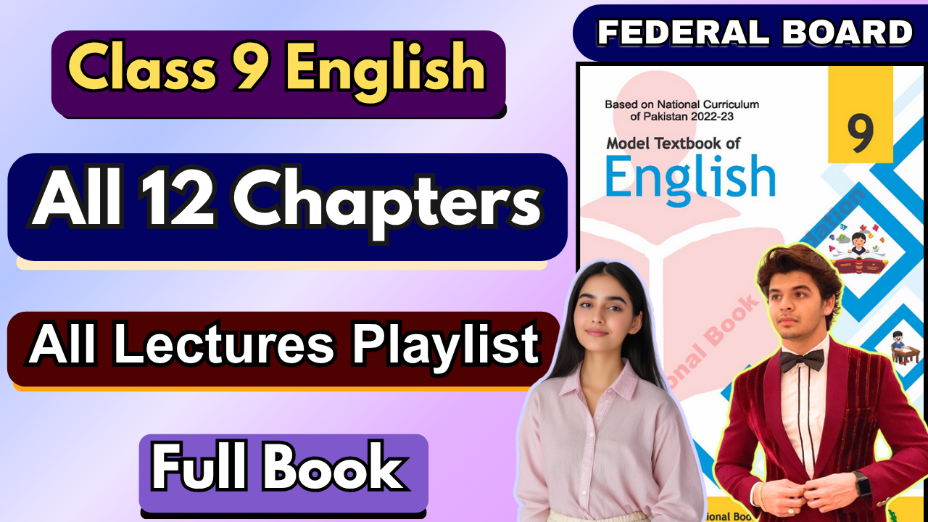

# 

**Glossary:**

**Given below are the difficult words from the unit. Look at their meanings and use these words in your own sentences.**

| **Words** | **Meaning** |
| --- | --- |
| navigate | to find one’s way through a situation, obstacle, or environment |
| debilitating | causing severe weakness or impairment |
| frustration | feeling of annoyance or disappointment when A facing obstacles |
| stability | state of being firm, steady, or unchanging |
| gauged | measured or determined |
| tangible | capable of being touched |
| impediment | an obstacle or hindrance |
| ample | more than enough, sufficient |
| resilient | able to bounce back from setbacks |
| discrimination | unjust treatment based on certain characteristics |

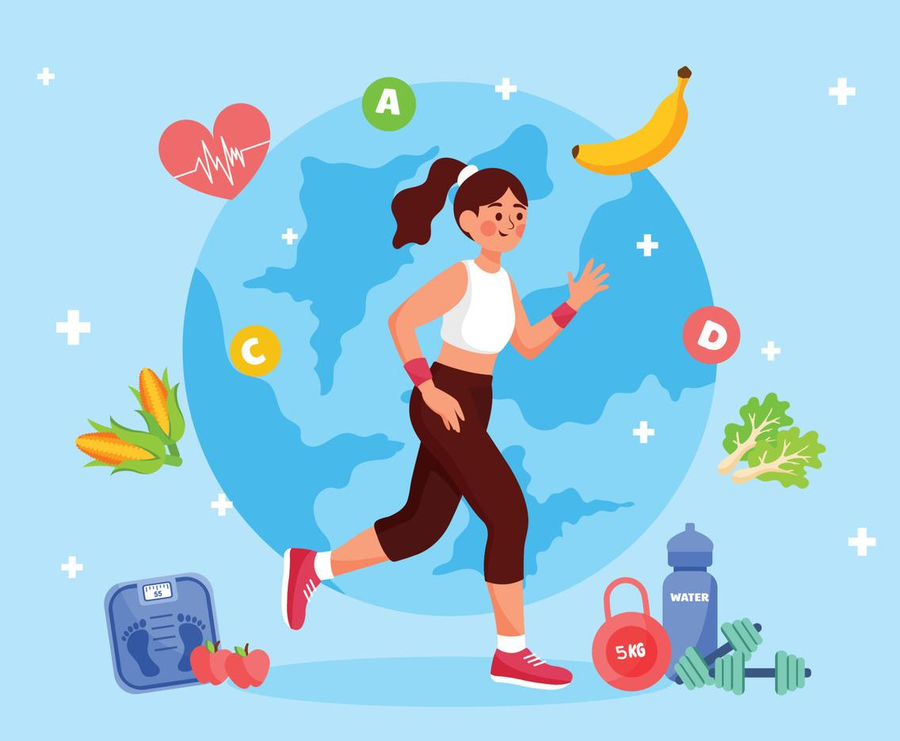

The following are the sentences for the above mentioned words:

1. **Navigate** – We used a map to navigate through the narrow streets of the old city.
2. **Debilitating** – The athlete overcame a debilitating injury after months of therapy.
3. **Frustration** – Her frustration grew when the computer kept crashing during her work.
4. **Stability** – After years of struggle, their family finally achieved financial stability.
5. **Gauged** – The teacher gauged the students’ understanding through a short quiz.
6. **Tangible** – The scientist needed tangible evidence to support her claim.
7. **Impediment** – Fear can be an impediment to success if we do not overcome it.
8. **Ample** – There was ample food at the party, so no one left hungry.
9. **Resilient** – Children are often resilient and recover quickly from setbacks.
10. **Discrimination** – Laws were introduced to protect people from discrimination at the workplace.

**Reading and Critical Thinking Skills**

**A. Reading Comprehension Questions:**

### Q1. Do you think health and well-being are connected or different concepts? Explain.

Ans. Health and well-being are connected, but they are not exactly the same.  
 The text explains that **health** means being free from injury or illness. It has two parts:

* **Physical health** – a strong, disease-free body
* **Mental health** – a strong mind, free from excessive stress, anxiety, or sadness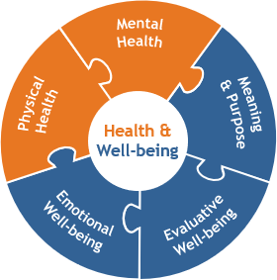

**Well-being**, however, is a broader concept. It includes not just the absence of illness but also **mental, emotional, and physical balance**.

So, while health focuses on the absence of disease, well-being focuses on overall stability, happiness, purpose, relationships, and how fulfilled a person feels. They are different concepts, but they deeply influence each other.

### Q2. How can you define well-being? Describe its types as well.

Ans. W**ell-being** means maintaining physical, mental, and emotional stability—not just avoiding illness, but achieving balance in life.

There are **two types of well-being**:

**Objective well-being**

* Based on basic human needs: food, education, shelter, safety, health
* Influenced by social, cultural, and political situations
* Measured through people’s living conditions

**Subjective well-being**

* Based on how people *feel* about their lives
* Includes happiness, satisfaction, relationships, social belonging, and sense of purpose

When objective and subjective well-being combine, a person experiences overall wellness.

### Q3. Is stress an impediment in the way of achieving the goal of healthy living? How?

Ans. Yes. S**tress is a major obstacle to healthy living**.

* People facing excessive stress are more likely to develop **depression**
* Depression decreases well-being and affects physical health
* Stress lowers a person’s ability to perform daily tasks properly
* It causes physical issues such as sleep problems, exhaustion, memory issues, and even weight changes



### Q4. What are the ways through which you can improve your overall health?

Ans. The text provides several ways to improve health and well-being:

1. **Connect with others**
   * Social relationships improve emotional health and happiness.
2. **Be physically active**
   * Exercise improves sleep, mood, and reduces anxiety and depression.
3. **Learn new skills**
   * Builds confidence, slows aging of the brain, and gives a sense of purpose.
4. **Be generous**
   * Helping others increases happiness and life satisfaction.
5. **Pay attention to the present (Mindfulness)**
   * Reduces stress, anxiety, and helps people stay calm and focused.

Together, these habits strengthen both mental and physical health.

### Q5. Well-being is more than happiness and life satisfaction. Do you agree?

Ans. Yes. Well-being is not only feeling happy or satisfied. It also depends on:

* Physical health
* Safety and basic needs
* Mental stability
* Strong relationships
* Absence of discrimination or fear
* Sense of meaning and purpose in life

This shows that well-being is a *complete state* of health—emotional, physical, psychological, and social—not just happiness.

### Q6. How does modern lifestyle affect our physical and mental health? Give real-life examples.

Ans. Modern lifestyle often harms both physical and mental health:

* High-pressure jobs cause stress, depression, and emotional exhaustion
* Long working hours reduce sleep and physical activity
* People disconnect from relationships and social support
* Technology-based work makes people sit for long hours, causing health problems



**Real-life example include:**

* Programmers and delivery workers in tech companies face extreme pressure
* Many sleep at their desks, have strict goals, and work nonstop
* This results in serious stress, high injury rates, and poor employee well-being

This example clearly shows how modern working habits can damage health.

# Vocabulary and Grammar Questions

### Adjectival Phrase

**Definition:** A group of words that functions like an adjective. It describes or provides more information about a noun or pronoun.

**Characteristics:**

* Tells what kind, which one, or how many.
* Often begins with prepositions or participles.

**Examples:**

* The girl **with long hair** won the race.  
   (Describes “girl”)
* I saw a boy **full of energy**.  
   (Describes “boy”)
* This is the house **built of wood**.  
   (Describes “house”)

*Read more at: (*[*https://quillbot.com/blog/adjectives/adjective-phrase/*](https://quillbot.com/blog/adjectives/adjective-phrase/)*)*

### Prepositional Phrase

**Definition:** A phrase that begins with a preposition and ends with a noun or pronoun (the object of the preposition).

**Structure:** Preposition + Object

**Functions:**

* Can act as an adjective (describing a noun)
* Can act as an adverb (describing a verb, adjective, or another adverb)

**Examples:**

* The cat is **under the table**. (Tells where)
* The book **on the shelf** is mine. (Describes book)
* She will return **after the holidays**. (Tells when)

*Read more at: (*[*https://www.grammarly.com/blog/parts-of-speech/prepositional-phrase/*](https://www.grammarly.com/blog/parts-of-speech/prepositional-phrase/)*)*

### Adverbial Phrase

**Definition:** A group of words that functions as an adverb. It modifies a verb, adjective, or another adverb.

**Shows:** How, where, when, why, or to what extent.

**Examples:**

* He spoke **in a loud voice**. (How)
* They arrived **at midnight**. (When)
* She stood **near the door**. (Where)
* The player ran **with great speed**. (How)

*Read more at: (*[*https://www.scribbr.com/sentence-structure/adverbials/*](https://www.scribbr.com/sentence-structure/adverbials/)*)*

# Q1: Highlight the adjectival phrases in the following sentences

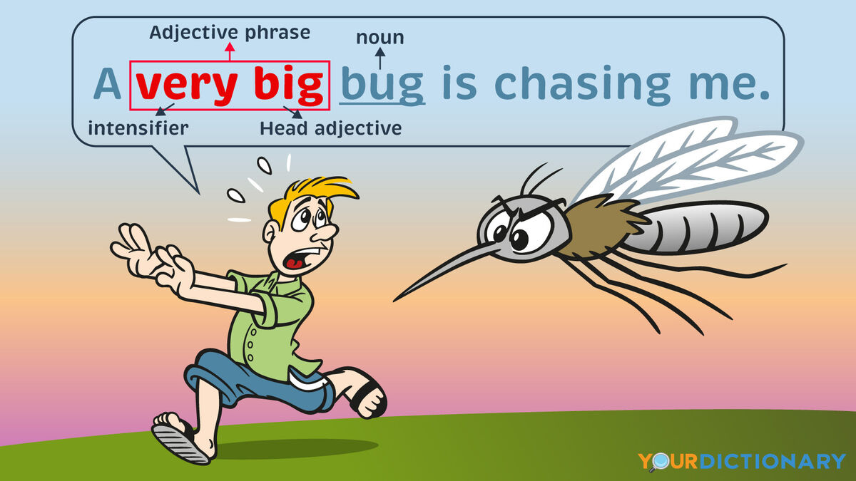

1. **The boy in the red shirt** is new here.   
   *(Adjectival phrase: "in the red shirt")*
2. **Which one of your trips** would you describe as **the most adventurous one**?

*(Adjectival phrases: "of your trips", "the most adventurous one")*

1. **Is the bag by the table** yours?   
   *(Adjectival phrase: "by the table")*
2. **Are you shorter than your brother**?   
   *(Adjectival phrase: "than your brother")*
3. **The boy with the Porsche** was noticed by everyone.   
   *(Adjectival phrase: "with the Porsche")*
4. **Can you buy me a box of white homemade chocolates** when you come back?  
   *(Adjectival phrase: "of white homemade chocolates")*
5. **The red-haired Portuguese boy** impressed all his teachers in no time. *(Adjectival phrase: "red-haired Portuguese")*
6. **All the children have read the play about the poor man and the king**. *(Adjectival phrase: "about the poor man and the king")*
7. **The city is expecting very few sunny days** this month.   
   *(Adjectival phrase: "very few sunny")*
8. **The tall Egyptian building** is one among the wonders of the world. *(Adjectival phrase: "tall Egyptian")*

# Q2: Circle all the prepositional phrases in the following sentences

1. After the movie, the group of teenagers went to a restaurant for a burger.  
   (**Prepositional phrases**: "After the movie", "of teenagers", "to a restaurant", "for a burger")
2. Without sugar, the blueberries were too sour for the dinner guests.  
   (**Prepositional phrases**: "Without sugar", "for the dinner guests")
3. Sally worked from midnight to noon on her science project.

(**Prepositional phrases:** "from midnight to noon", "on her science project")

1. Over the river and through the woods to grandfather’s house we go.

(**Prepositional phrases**: "Over the river", "through the woods", "to grandfather’s house")

1. He ate three boxes of popcorn with butter during the movie.   
   (**Prepositional phrases**: "of popcorn", "with butter", "during the movie")
2. Despite his fear of water, Jack saved the drowning puppy.   
   (**Prepositional phrase:** "Despite his fear of water")
3. Janet took her lunch with her to the seminar.   
   (**Prepositional phrases**: "with her", "to the seminar")
4. At the Country Fair, the child with the freckles won the talent contest. (**Prepositional phrases**: "At the Country Fair", "with the freckles")
5. For breakfast, she likes bananas with strawberries.   
   (**Prepositional phrases**: "For breakfast", "with strawberries")
6. Down the dark alley, the cat chased a rat with long whiskers.   
   (**Prepositional phrases:** "Down the dark alley", "with long whiskers")

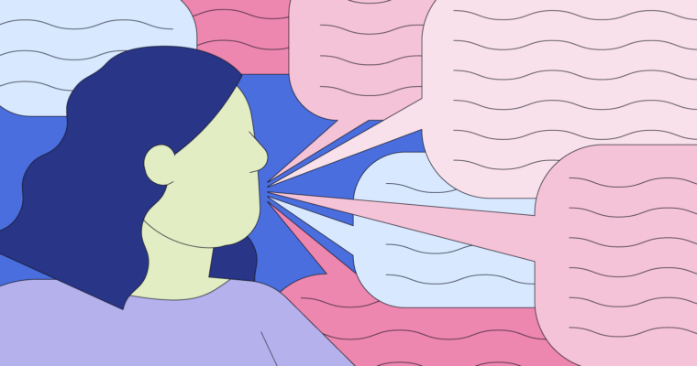

**Q3: Find the adverbial phrases in the following sentences**

1. **The salesman went door to door** to promote his new product.   
   *(Adverbial phrase: "door to door")*
2. **The girls were running to and fro**.   
   *(Adverbial phrase: "to and fro")*
3. **They left their home country to pursue better opportunities in a foreign country**.

*(Adverbial phrase: "to pursue better opportunities in a foreign country")*

1. **His reputation as a lawyer spread far and wide**.   
   *(Adverbial phrase: "far and wide")*
2. **You can find that brand at all places that sell cosmetics**.   
   *(Adverbial phrase: "at all places that sell cosmetics")*
3. **The crime scene investigator found a clue on this spot that led to the perpetrator’s arrest**.   
   *(Adverbial phrase: "on this spot that led to the perpetrator’s arrest")*
4. **Rocky ran at a great speed to win the race**.   
   *(Adverbial phrase: "at a great speed to win the race")*

# Q4: Identify the phrases in the passage and categorize them into the table

**Ans.** From the passage, here are some identified phrases:

**Adjectival Phrases:**

* **"a vibrant tapestry of wild lilies"**
* **"a family of bumblebees"**
* **"the glowing blossom"**
* **"the birds with freckles"**

**Prepositional Phrases:**

* **"Across the bright green landscape"**
* **"Among them, an elegant, crimson poppy"**
* **" Toward the snow-capped peaks"**
* **"Through the pastures"**

**Adverbial Phrases:**

* **"In the heart of a serene, sun-sunny meadow"**
* **"With lots of colors"**
* **"Babbling happily as it journeyed"**
* **"Increasing the beauty of countryside"**

# Descriptive Essay

**Use Sensory Details**

Describe how your subject looks, smells, feels, sounds, and even tastes (if applicable).

Example (describing a bakery):

* Sight: "Golden loaves of bread rest in neat rows, their crusts glistening under the warm bakery lights."
* Smell: "The air is thick with the aroma of fresh vanilla, cinnamon, and melting butter."
* Sound: "The steady hum of the oven and the occasional ding of the timer fill the cozy space."
* Touch: "The soft, warm pastry crumbles slightly as I take my first bite."

**Structure Your Essay**

**Introduction**

* Start with a **hook** (a question, a quote, or a vivid sentence).
* Introduce your topic and provide background.
* End with a **thesis statement** (the main idea of your description).

**Body Paragraphs (2-3 paragraphs)**

* Each paragraph should focus on different aspects of your subject.
* Use **sensory details** and figurative language (similes, metaphors, personification).
* Arrange details in a **logical order** (spatial order, chronological order, or importance).

**Conclusion**

* Summarize the main points.
* Reflect on why the subject is meaningful.
* End with a strong final impression.

**Tips for Writing a Great Descriptive Essay**

* **Show, don’t tell** – Instead of saying, "The cake was delicious," describe its rich flavor and soft texture.
* **Use figurative language** – Similes, metaphors, and personification make descriptions more engaging.
* **Organize details logically** – Move from general to specific or follow a natural flow.
* **Revise and edit** – Check for clarity, unnecessary words, and spelling/grammar errors.

**Example Descriptive Essays:**

# A Walk Through the Market

The aroma of sizzling kebabs and fresh naan fills the air as I step into the bustling bazaar. The chatter of vendors bargaining with customers blends with the rhythmic clinking of bangles and the honking of rickshaws. Brightly colored stalls overflow with spices, their rich hues of red, yellow, and orange painting a mesmerizing picture.

As I weave through the crowd, I pause at a fruit stall where ripe mangoes glisten under the golden sunlight. The vendor, a kind elderly man, hands me a slice, and the juicy sweetness explodes in my mouth. The warmth of the sun, the buzz of voices, and the vibrant chaos of the market create an experience that is both overwhelming and exhilarating. Every visit to this market is a journey through colors, sounds, and flavors that define the heart of the city.

# A Visit to the Bakery

The moment I step into the bakery, a wave of warmth embraces me, carrying the scent of freshly baked bread, sweet vanilla, and melting butter. The golden glow of the lights reflects off trays lined with flaky croissants, delicate pastries, and crusty loaves, each arranged with precision. Behind the glass counter, a rainbow of macarons sits in neat rows, their pastel shells crisp yet soft.

The gentle hum of the oven, the rhythmic clatter of metal trays, and the soft laughter of the baker working behind the counter create a comforting symphony. A warm cinnamon roll, dusted with powdered sugar, melts in my mouth, its sticky glaze leaving a trace of sweetness on my fingertips. Every visit to the bakery is a journey through flavors, textures, and the simple joy of homemade goodness.

# A Walk in the Park

The park awakens with the golden touch of sunrise, its lush green carpet sprinkled with morning dew. Tall trees stretch their arms toward the sky, their leaves whispering secrets as the breeze rustles through them. The chirping of birds creates a melody, harmonizing with the distant laughter of children playing near the swings.

A cobbled pathway winds through a bed of vibrant flowers—roses, daisies, and tulips—each swaying gently as if greeting the passersby. The scent of fresh grass and damp earth fills the air, mingling with the faint aroma of blooming jasmine. As I sit on a wooden bench, a gentle breeze brushes against my face, carrying with it the laughter, rustling leaves, and the peaceful hum of nature. The park is not just a place; it is a sanctuary of calm, a retreat from the chaos of the world.

